For Shiasta

Chapter 100 Sizing, Shanks

I hope this explains it.

1. Most of the labor is a multiplier of Cell **C2,** sizing 14kt smaller.
2. 10kt is 90% of 14kt, 90% of C2, **bold is a** **sort of let’s you know that.**
3. 18kt sizing C8 is a multiplier of sizing 14kt smaller, cell again C2
4. Then each additional sizing for 18kt is a multiplier of Cc, then C9, then C10.
5. Palladium, Platinum and Silver are multiplier of **C2**, 14kt (Rows 11 thru 22)
6. Starting on row 23 we have in column”O” sizng larger. Look at Cell **O23** the $60.00 is the labor (jlrc0 to make a ring larger (first size only). Then each additional size larger, the labor is less, cell **P23**.
7. Column “Q” is now calculating the cost of th e metal going into the rng to make larger.

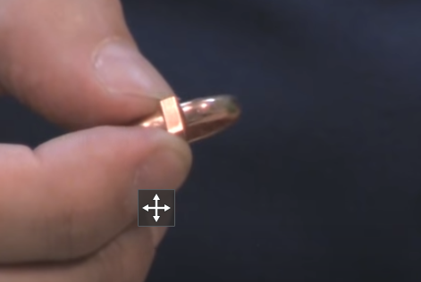

1. The Stuller number (example: SIZING STOCK:45500:P) is only for calculation for metal costing, we won’t order it. On Stuller, they sell this by the inch. There are 25millimters to an inch so the jeweler, using their own stock, will only need 2.5 millimeters for that piece. So **column “S” tells you what percent of the stuller amount to use for cost of the metal.** In this case 10%. This is our **COST** like others multiply out cost times “3”
2. Columns “O” & “P” are the JLRC amount, so these are retail.

This is the cost the inch of 10kt is $37.14. So 10% of that, our cost for metal is 10% of $37.14 or $3.74.. Muiltiply x 3, metal retails for $11.22. Add to that the retail labor for one size larger (cell “O23”) of $60.00, one size larger retail is $71.00

Then 2 sizes larger is the $60.00 labor plus another $15.00 for the next size (column :P” (P23). The metal cost is 2 pieces of the $3.74 gold.

Labor: $60 + $15 = $75.00|| Gold is $11.22 x 2 sizes - $$22.44

$22.44 + 75.00. Retail is now $97.00

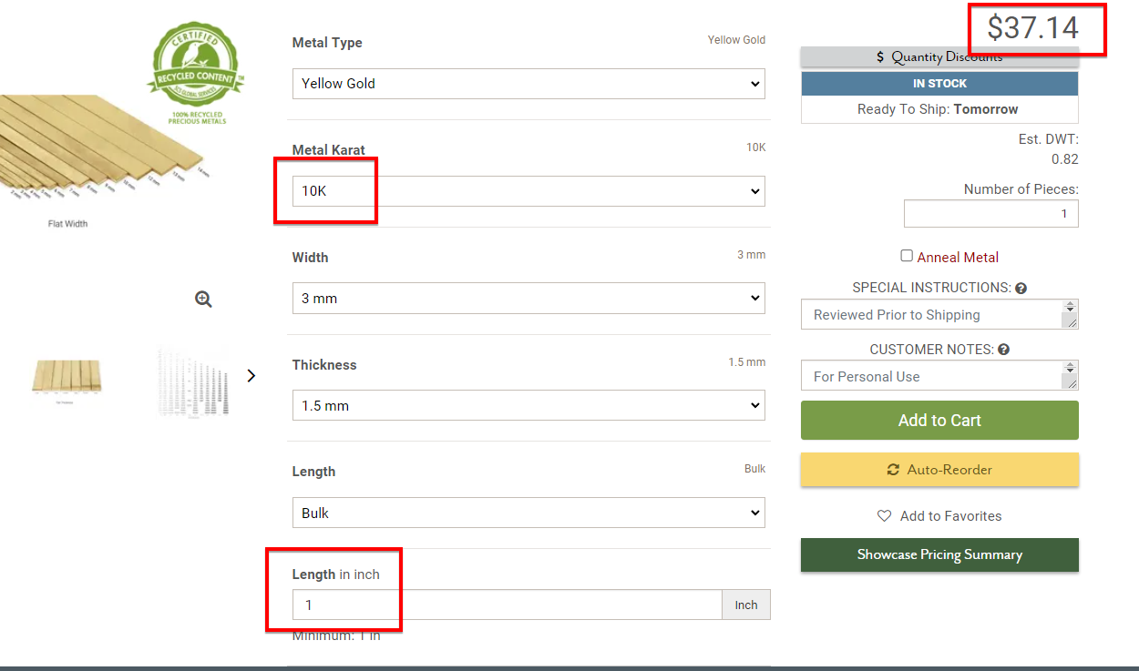

1. If you see orange color in column O that’s “each additional size larger” and probably works off of a multiplier of C2, the master sizing smaller.
2. Around row 63, there is nothing in columns L and to the right, all labor is in column D
3. D63 down is mostly a multiplier of C2, but starting at D69 down to D80, these are a multiplier of an actual number in Column D.
4. Magenta/pink colors refer to the right, column “U”
5. Green color is a multiplier of cells C63 thru C83
6. Purple shows the cells are a multiplier of cells above in column D.
7. Blue is a percentage of Column O.
8. Drak Orange colors refer back to the top “C”2”.
9. Rows 316 down to 328, column D is the retail labor to install (JLRC) and cells “Q312” down to “Q328 are Stuller stock numbers and you can have the pop up “would you like to place this on a pick list? (because it comes from Stuller.